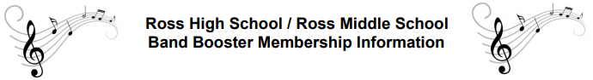

The Ross Band Boosters were organized in 1980 to provide support for the instrumental music programs at Ross High School and Ross Middle School. Purchasing uniforms, instruments, music equipment, and band and color guard awards are just some of the ways this organization supports these programs through this fundraiser.

Ross Local School District has an outstanding instrumental music program. This is possible because of the efforts and support of our Band Boosters.

Any parent or community member is eligible and encouraged to join. Meetings are generally held the first Tuesday of every month at 6:30pm in the Ross High School Band room located at the rear of the building, door number 6. All Band Boosters members are encouraged to attend, but it is not a requirement.

As a show of appreciation, Booster members are listed in the concert programs for the high school and middle school band concerts.

If you have questions, please contact Jennifer Estridge at (513) 207-4297 or sjestridge@gmail.com.

Please make checks payable to Ross Band Boosters and mail with the completed form directly to Ross High School, 3601 Hamilton Cleves Road, Hamilton, Ohio 45013 Attn: Band Boosters or you can send it in with your student to their band director. You can also use Venmo @Ross-BandBoosters. Please add a note with your name as you’d like it to appear in the concert programs and your students name.

Thank you for your support!
Jennifer Estridge, Membership Chairperson
*********************************************************************************
Ross Band Booster Membership Form

Name: _______________________________ Student Name: ______________________
(Please list name(s) as you want it to appear in the concert programs)

Address: ______________________________________________ Zip: ________

Phone: _________________ Email: _____________________________________

Membership type: _____ Single $10.00 _____ Family $ 20.00 _____ Patron $30.00

_____ Maroon & Gold $50.00 _____ Maroon & Gold Supreme $75.00 & up

_____ Directors Circle $250.00 & up

_____ Alumni $10.00 (Grad Year:________ Instrument:_____________)
***Please make checks out to Ross Band Boosters

